Supported by
Organized by
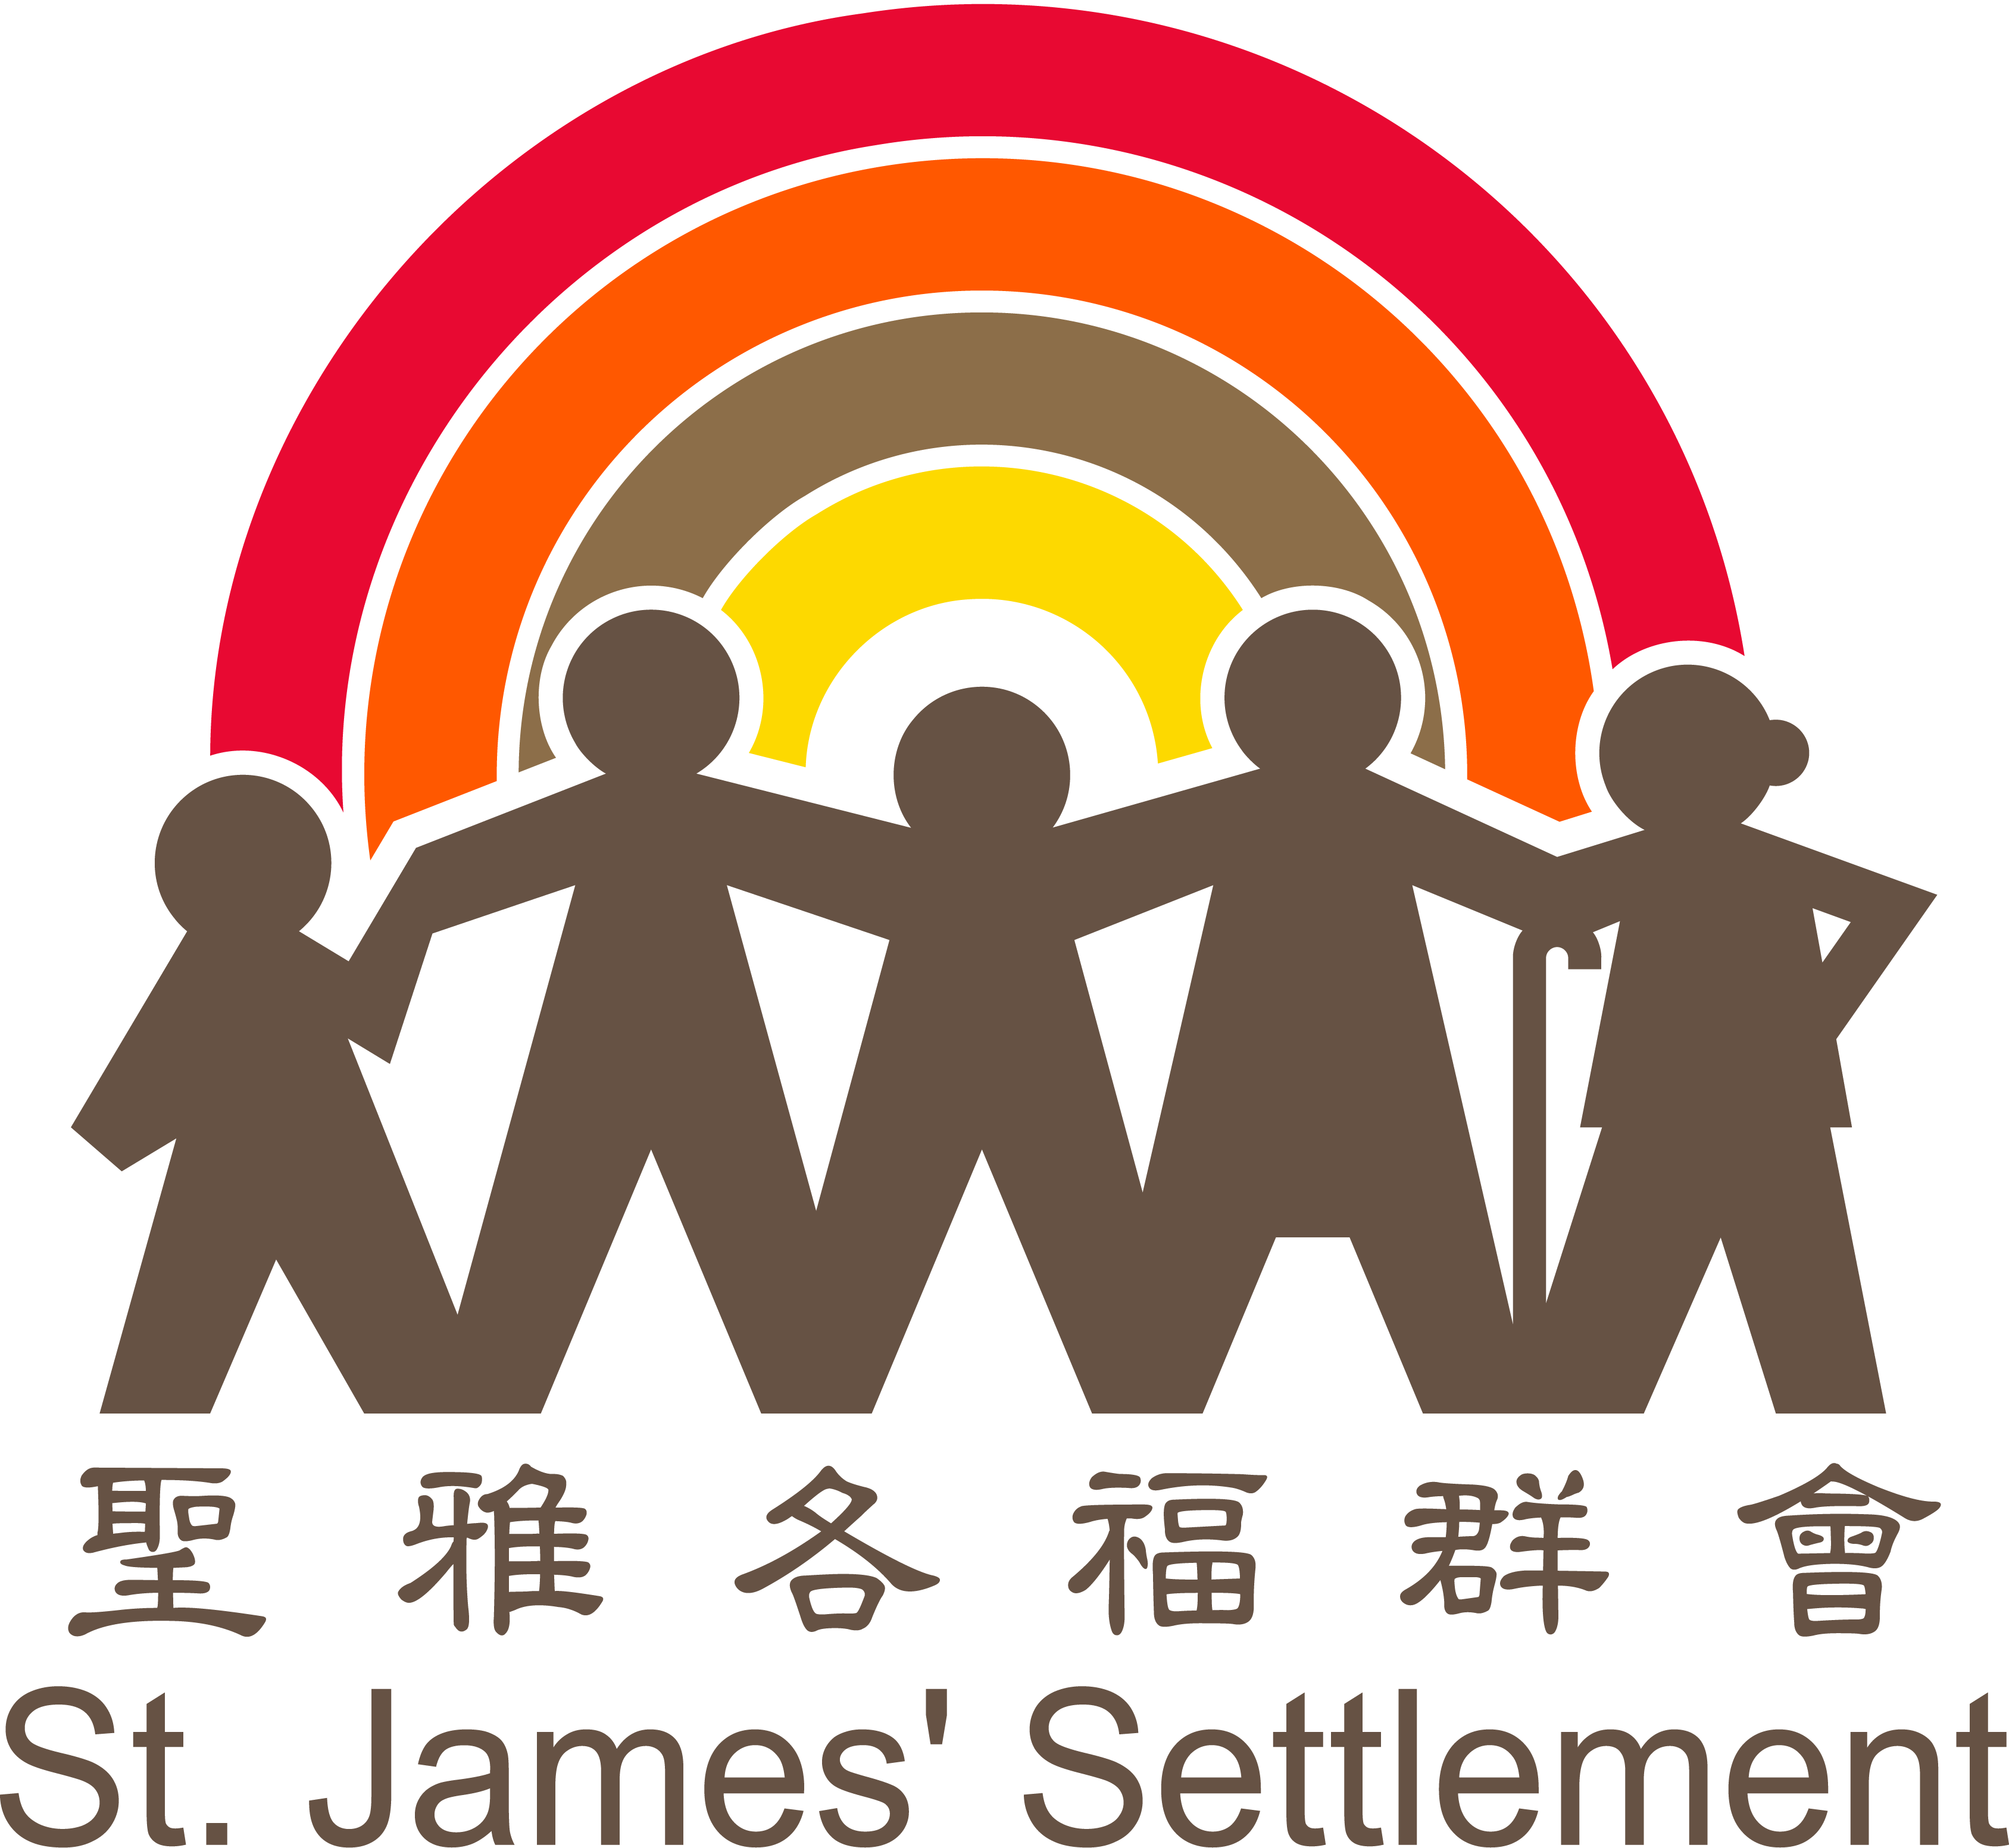
Co-organized by

Enrollment Form for “Serve With A Purpose” Program 2020-21
「愛．精彩社區」大專生服務學習計劃2020-21申請表

NOTES: | 備註：
1. Please complete the form clearly.  2. You may request for correction of personal data in writing to our Youth Services of St. James’ Settlement after submission of this application.  - Information on unsuccessful candidates will be destroyed after the recruitment exercise when such information is no longer required.  - Please submit completed application form to scds@scs.cuhk.edu.hk.  - Application Deadline: 30 Nov 2020 noon | 1. 請以正楷填寫此表格。  2. 遞交申請表格後，如欲更改填報資料，請以書面通知聖雅各福群會青年服務。  - 甄選程序完成後，未獲取錄申請人的資料如已毋須保留，將全部銷毀。  - 請將填妥之報名表電郵至scds@scs.cuhk.edu.hk  - 截止報名日期：30/11/2020 中午12時正  (以收到報名表時間作準。)

- Personal Particulars個人資料
Surname姓氏 | Other Names名字 | Name in Chinese中文姓名 | Gender性別
Correspondence Address  通訊地址 |  | Student No.  學生編號
Programme Studying
就讀學科
Year of Study
就讀年級
Hong Kong Identity Card No.  香港身份證號碼 |  | Mobile No.  手提電話號碼
Email Address *將透過此登記電郵，通知有關申請事宜  電郵地址 |  | Home No.  住所電話號碼

- Education and Training (in chronological order) 教育及訓練（依時間先後列出）
Dates (Month/Year)  就讀日期﹙月／年﹚ |  | Name of Institution(s) / Organization (s)  就讀學校/培訓機構 | Class(es) Attended/Attending  就讀班級
From 由 | To 至

- Work and Volunteer Experience (in chronological order) 工作及義務工作經驗（依時間先後列出）
Dates (Month/Year)  工作日期﹙月／年﹚ |  | Name of Employer/Service Agency  工作 / 服務機構 | Full Time全職 | Part Time  兼職 | Volunteer work  義工 | Post and Job Description  職位及工作簡述
From由 | To至

- Financial Situation 經濟狀況 (Please “” as appropriate 請在方格內加入「」號)
Please submit supporting documents with the application form. 請連同申請表，提交有關證明文件。

- Did anyone of your household receive Comprehensive Social Security Assistance (CSSA) for the period 1.9.2019-31.8.2020?
你或你的家庭在過去十二個月內有否接受綜合社會保障援助(綜援)計劃之援助？
Yes有 No沒有

- Did anyone of your household apply for Financial Assistance Scheme / Loan Scheme?
你或你的家庭成員有沒有申請學生資助或貸款計劃？
Financial Assistance Scheme for Post-secondary Students (FASP)專上學生資助計劃
Non-means-tested Loan Scheme for Post-secondary Students (NLSPS)專上學生免入息審查貸款計劃
No沒有 Others 其他 (Please specify請註明：___________________________________ )

- Did anyone of your household have special financial needs?
你或你的家庭成員有沒有特別經濟需要？
Yes有 (Please specify請註明：________________________________________ ) No沒有

- Additional information附加資料 (Special circumstance that have not been mentioned above可補充說明上列未有反映的情況)

(Please use separate sheets if necessary 如有需要可附另頁詳列)

- Special Strengths & Skills 個人專長/技能
Computer Skills
電腦技能
Language
語言
Music / Art / Sports
音樂 / 藝術 / 運動
Others strengths / skills
其他專長 / 技能

- Interview Timeslot Preference 面試時間選擇
Please “” as appropriate and select as many as possible to ensure a favorable allocation 請在方格內加入「」號，並盡量選擇更多時段，以便面試安排

 | 1/12/2020 (星期二)  將軍澳教學中心 | 3/12/2020 (星期四)  尖沙咀東海教學中心 | 4/12/2020 (星期五)  將軍澳教學中心
下午5:00-8:00
(5:00pm-8:00pm)

- About Applicant 關於申請人
- Why do you apply for this project？你為何參加這項計劃？

- What is/are your strength(s) and weakness(es)？你認為自己有什麼優點和缺點？

- Under Covid-19, which target group in the society do you think needs help? What do you suggest?
你認為疫情下，社會上那個群組人士需要得到協助? 有何建議?

- Declaration 聲明
- I understand that if I give any false information or withhold any material information, I shall render myself liable to dismissal if I am selected to participate in this programme.
本人明白倘若虛報資料或隱瞞重要事實，即使已獲准參與此計劃，亦有被取消參與計劃的可能。

- I understand that I have to attend ALL activities and finish ALL assignments if I am admitted to the programme, otherwise, I may be disqualified from taking part in the programme.
本人明白接納取錄後，必須出席計劃內的全部活動並完成相關習作，否則將有可能被取消參加資格。

- I understand that I will not be granted with certificate and sponsorship if I withdraw from the programme at any stage with personal reasons or being disqualified.
本人明白，如在計劃期間因個人原因申請退出或被取消參加資格，均不會獲發證書及獎助金。

- I, do hereby consent and agree that Organizers and Sponsor have the right to take photographs, videotape, or digital recordings of me during the project and to use these in any and all media, now or hereafter known.
本人同意主辦及贊助單位對我進行拍攝或錄音，無論事先、事後告知，主辦及贊助單位均可通過各種媒介（包括書籍、新聞稿、網站等）展示有關照片、影片及錄音。

- St. James’ Settlement undertakes to comply with the requirements of the Personal Data (Privacy) Ordinance to ensure that personal data collected are properly stored. The personal information will be used for program selection and other related purposes. St. James’ Settlement may use your personal data (name, telephone number, fax number, email and mailing addresses) for the purposes of providing you with information of St. James’ Settlement, fundraising appeal, activities / courses invitation as well as for feedback collection and related promotion purposes. However, we cannot use your personal data unless we have received your consent. Upon your request at any time and at no charge, we will cease to use your personal data for promotion purposes.
聖雅各福群會盡力遵守《個人資料(私隱)條例》所列載的規定，依照收集資料時所說明的目的使用該等資料，並確保個人資料得到妥善儲存。閣下提供予本會的個人資料將用作甄選計劃及計劃有關事宜之用。本會將運用閣下之個人資料(包括姓名、電話、傳真、電郵及郵寄地址等)，以便日後作與閣下通訊、服務推廣、呼籲慈善捐款、活動/訓練課程邀請或收集意見的用途。除非本會已取得你的同意，否則本會不會使用你的個人資料作上述用途。閣下可以隨時向本會提出要求停止使用閣下的個人資料，此項 安排毋須繳付任何費用。

Should you find such use of your personal data not acceptable, please indicate your objection before signing by ticking the box below.
如閣下不同意上述安排，請在簽署前於以下空格加上「×」號。

I do not agree to the proposed use of my personal data as stated above.
本人不同意上述有關使用個人資料的安排。

簽署：_______________________________ 日期：_____________________________

Appendix 1
"Serve With A Purpose" Program 2020-21
Program Stages

“Serve With A Purpose” Program 2020-21 (SWAP) is a service learning project that combines community service and with tuition support.

Benefits of the Students:
- Help to speed up the recovery and build up the positive society under COVID 19
- Identify and develop the technical and life skills – financial literacy, communication, collaboration, problem solving and time management
- Develop a sense of social responsibility among youth and enlarge the social impact through individuals
- Have a better understanding of their personal strengths, abilities and values by completing the social design project proposal
- Support students by tuition (HKD 3,000) after finishing the program.

Your Roles and Responsibilities:
- Use knowledge, talents and skills to plan and implement a social design project and serve the target group which influenced by Covid-19.
- Actively participate in ALL orientation, ceremonies, trainings, consultation meetings, evaluations and social design activities.
- Be respectful to the service targets’ privacy and dignity, as well as the general practices of the service unit.

You will go through the following stages (100 hours) throughout the program. Guidance will be provided in different stages by St. James’ Settlement and CUSCS.
- Program Introduction & Recruitment (9 Nov – 30 Nov 2020)
- Submit the Enrollment Form and supporting documents for financial need.
- Select your available interview timeslots in Enrollment Form.
- Interview (1-4 Dec 2020)
- Meet program organizers and sponsor.
- Understand program requirements.
- Program Orientation Camp (28-29 Dec 2020)
- Get familiar with the program staff and other students.
- Understand project details especially social design learning project.
- Set personal goals for the program.
- Provide a platform for you to ask questions.
- Understand personal character and team building.
- Self-Understanding Workshop (31 Dec 2020)
- Understand yourself and others with more effective in your service learning.
- Use a convenient card sort and short questionnaire to reveal your personality in four colors.
- Life Goal Setting Workshop (6 Jan 2021)
- Consolidate your personal views through the designated game cards.
- Topic can be covered: Value, Personal Relationship, Ability and Passion.
- Digital Skills Workshop (17 Jan 2021)
- Consolidate your personal views through the designated game cards.
- Topic can be covered: Value, Personal Relationship, Ability and Passion.
- Social Design Learning Training (30-31 Jan 2021)
- Learn the most basic concepts and tools related to social design learning project through interactive and creative game
- Personal Finance Training (20 Feb 2021)
- Have a sense of manage money.
- Know more about the ways for better financial management.
- User Research & Community Study (6-27 Feb 2021)
- Find out the causes and problems of particular service target through real time observation and interview.
- Voluntary Activity in SJS (Feb-Apr 2021)
- let the students feel their impact through volunteering and interacting with the community
- Social Design Learning Project Proposal & Prototype (1 Mar – 7 May 2021)
- Execute the ideas and create prototype by using different resources.
- Tackle the particular problem and evaluate impact.
- Pitching Training (8 May 2021)
- Understand what preparation is needed in professional pitching
- Equip the techniques to transform personal experience to an engaging pitching
- Closing Ceremony and Program Evaluation (28 May 2021)
- Oral presentation on your service experience.
- Reflect and exchange ideas with project staff and other students.
- Share your service experiences and learning outcomes with organizers, sponsor and media.
*Disclaimer: Program dates are subjected to change, and you will be informed accordingly.*

Appendix 2
Serve With A Purpose (SWAP) Program 2020-21
Program Content
- Program Content
Training Session | Hours
Orientation Camp (2D1N) | 17
Self-Understanding Workshop | 6
Personal Financial Management Training | 3
Life Goal Setting Workshop | 3
Digital Skills Workshop | 6
Pitching Training | 3
Program Evaluation | 2
Closing Ceremony | 3
Service Learning | Hours
Social Design Learning Training | 12
User Research and Community Study | 12
Social Design Learning Project Proposal & Prototype | 30
Voluntary Activity in SJS | 3
Total: | 100

- Activity Content
Date | Time / Venue | Content
28-29 Dec 2020  (Mon-Tue) | 10:00a.m. – 7:00p.m.  10:00a.m. – 8:00p.m.  Venue: SJS | Orientation Camp (2D1N)
31 Dec 2020  (Thu) | 10:00a.m. – 1:00p.m.  Venue: SJS | Self-Understanding Workshop
6 Jan 2021  (Wed) | 10:00a.m. – 5:00p.m.  Venue: SJS | Life Goal Setting Workshop
17 Jan 2021  (Sun) | 10:00a.m. – 5:00p.m.  Venue: SJS | Digital Skills Workshop
30-31 Jan 2021  (Sat-Sun) | 10:00a.m. – 5:00p.m.  Venue: SJS | Social Design Learning Training
6 Feb to 27 Feb  (Fixed on 6 Feb and 27 Feb to have a session) | 6/2 and 27/2: 10:00a.m. – 1:00p.m.  Venue: SJS and On Site Activity  *Other hours are based on group schedule | User Research & Community Study
1 Feb to 30 Apr 2021 | 3 hours  Venue: On site Activity  *Schedule to be confirmed | Voluntary Activity in SJS
20 Feb 2021  (Sat) | 10:00a.m. – 1:00p.m.  Venue: SJS | Personal Financial Management Training
1 Mar – 7 May 2021 | 30 Hours  Venue: On site Activity  *Hours are based on group schedule | Social Design Learning Project Proposal & Prototype
8 May 2021  (Sat) | 10:00a.m. – 1:00p.m.  Venue: SJS | Pitching Training
28 May 2021  (Fri) | 10:00a.m. – 3:00p.m.  Venue: SJS | Program Evaluation and Closing Ceremony
*Disclaimer: Program dates are subjected to change, and you will be informed accordingly

